Intelligent Building Report

## Abstract

Creating an intelligent building simulation using javafx and object oriented programming

## Object Oriented Analysis

Building – Stores the room and person classes. Handles setting up paths for the people in the building.

Room – Contains thing class objects and manages their actions in the building

## User Manual

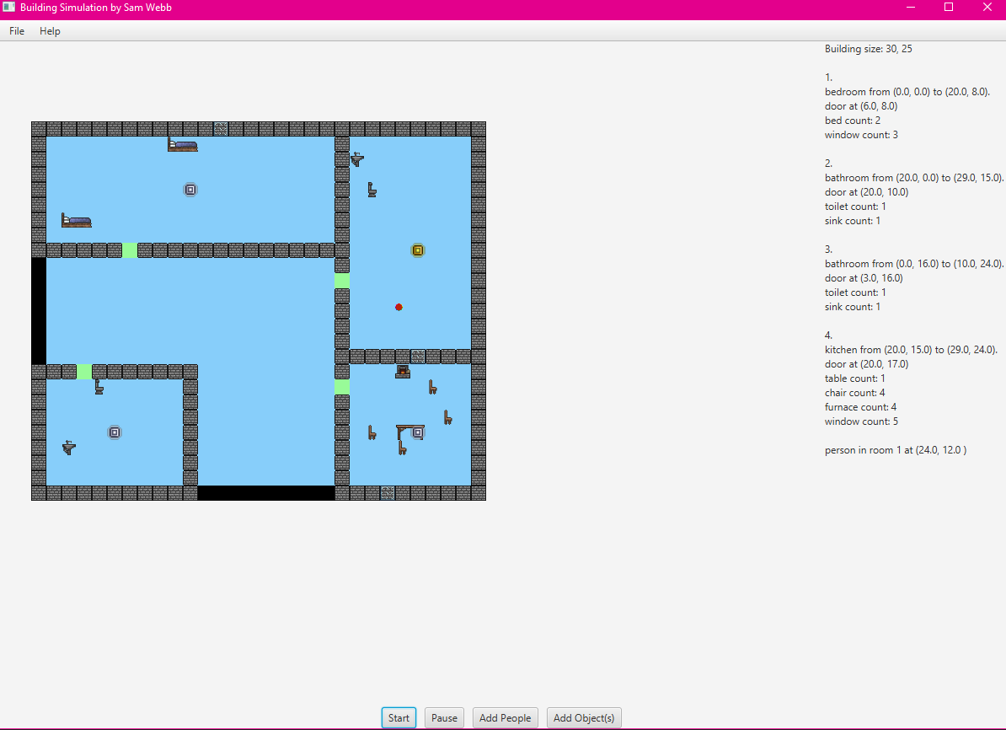

Information about the current building

Buttons to interact with the simulation

Display showing the building with animation

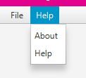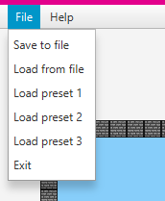

Information about the program itself

Options for loading, saving and exiting

## Testing

|  |  |  |  |
| --- | --- | --- | --- |
| Actions performed | Expected output | Actual output | Solution (if required) |
| Add object with incorrect type “test”, count 2 and room 1 | Message displays in console informing user that the type is invalid | As expected |  |
| Add object |  |  |  |
|  |  |  |  |

## Discussion and Reflection